FORMAT FOR A REVIEW PAPER

Title page:

TITLE:

A COMPREHENSIVE REVIEW ON AI BASED SMART SECURITY SYSTEM

|  |  |
| --- | --- |
| 22491A0568 | ATHANTI AMULYA |
| 22491A0570 | BADRI VENKATA THIRUMALA |
| 22491A0573 | BOGGU GRACY |
| 22491A0581 | EDUPULAPATI VENKATA JYOTHI SWAROOP |
| 22491A05A4 | MUDDANA SRI HARSHA |
| 22491A05C9 | BAPANAPALLI VENKATA PRASAD |

DATE:18/9/24

Abstract:

Security system is the development of an advanced security system utilizing artificial intelligence (AI) to enhance surveillance and threat detection capabilities. The system leverages AI technologies such as machine learning and deep learning to process and analyze data from various sensors and cameras. Key features include real-time facial recognition, behavioural analysis, and anomaly detection. By continuously learning from data, the AI-driven system adapts to new threats and reduces false positives, providing a more reliable and efficient security solution. This innovative approach aims to improve security measures in both residential and commercial settings, addressing complex and evolving security challenges with enhanced accuracy and responsiveness.

The smart security system that leverages artificial intelligence (AI) to enhance surveillance, threat detection, and response capabilities. The system integrates AI-driven technologies, including machine learning and computer vision, with IoT devices to create a cohesive security solution. By employing real-time data analysis, the system offers advanced features such as intelligent facial recognition, behavior analysis, and predictive threat detection. AI algorithms enable the system to adapt to new and evolving security threats, reducing false alarms and improving accuracy. Through remote access and automated alerts, the smart security system provides a scalable, efficient, and reliable solution for modern security challenges.

AI-based smart security system designed to revolutionize security management through advanced technologies. The system integrates artificial intelligence (AI) with smart devices and IoT infrastructure to offer a comprehensive security solution. AI algorithms power features such as real-time facial recognition, behavioral pattern analysis, and anomaly detection to enhance threat identification and response. The system's adaptive learning capabilities allow it to continuously improve its performance based on evolving data, minimizing false positives and ensuring accurate threat detection. With remote monitoring, automated alerts, and scalable architecture, this AI-based smart security system provides a robust and efficient solution for both residential and commercial security needs.

1.Introduction:

An introduction to a security system, especially one based on face detection and recognition using IoT, can highlight the importance of safety in modern homes and workplaces. Here's an example:

In smart security system is increasingly connected world, security has become a paramount concern for homes, offices, and public spaces. Traditional security systems, such as key-based locks and standard surveillance cameras, provide a basic level of protection but often fall short in addressing modern-day challenges. These systems are vulnerable to breaches and require manual monitoring, which may lead to human error or delays in response.To overcome these limitations, advanced security solutions are being developed using cutting-edge technologies like the Internet of Things (IoT), artificial intelligence (AI), and face recognition. IoT enables the integration of various devices—such as cameras, sensors, and alarms—into a unified system that can be monitored and controlled remotely. Face detection and recognition, powered by AI, add a layer of intelligence to these systems by identifying individuals in real-time and granting or denying access based on predefined criteria. This paper explores the design and implementation of a home automation security system that leverages IoT and face recognition technologies. The system aims to enhance safety and convenience by automating access control, monitoring environments, and sending real-time alerts in the event of unauthorized access. By combining the strengths of IoT and AI, this solution promises to offer a more secure, efficient, and user-friendly approach to home security.

AI-Based Security Systems is technology advances, the need for more intelligent and adaptable security systems has become paramount. Traditional security systems, while effective to an extent, often rely on manual monitoring and predefined rules, which can result in slow response times, false alarms, and the inability to handle evolving threats. To address these limitations, Artificial Intelligence (AI) has emerged as a game-changer in the security domain.

AI-based security systems leverage advanced technologies such as machine learning, computer vision, and natural language processing to provide smarter, faster, and more efficient security solutions. By integrating AI, these systems can analyze vast amounts of data in real time, recognize patterns, and autonomously make decisions to prevent or mitigate threats. AI enables security systems to continuously learn and adapt to new challenges, providing proactive and scalable protection for both physical and digital environments.

From facial recognition in access control systems to AI-powered intrusion detection and real-time video surveillance, the integration of AI into security systems enhances both efficiency and accuracy. AI’s ability to detect anomalies, predict potential security breaches, and reduce false alarms makes it a valuable tool for safeguarding homes, businesses, and critical infrastructures. As the threats to security evolve, so too must the tools we use to protect ourselves, and AI offers a forward-thinking solution that reshapes the landscape of security systems. This paper explores the applications, benefits, and future potential of AI-driven security systems, highlighting how AI enhances security beyond traditional methods.

2.LITERATURE REVIEW:

Sana Ghafoor [1] In this paper The smart security systems reveals a focus on integrating facial recognition with IoT to enhance home automation security. The system's reliability is increased by combining face detection with IoT, allowing for real-time monitoring and alerts. Advances in AI and machine learning have significantly improved the accuracy of facial recognition, making it a viable solution for smart home security. Recent studies highlight the importance of optimizing algorithms for low-power devices, ensuring the system's efficiency and responsiveness. Asif Rahim [2] in this paper they discuss about the Recent advancements in deep learning and IoT have significantly influenced facial recognition systems for smart home security. Research by Salim et al. developed a system with high accuracy but limitations in recognizing watermarked or tilted images. Ouanan et al. utilized CNN models for facial recognition in uncontrolled environments, achieving promising results despite ongoing challenges. Integration with IoT platforms, as explored by Hussain et al., enables real-time authentication with high accuracy. Prashant Katiyar[3] in this paper they discuss about the Recent studies on AIbased home security systems emphasize the integration of IoT, machine learning, and biometric technologies to enhance security. Katiyar et al. highlight how AI-driven systems, including smart cameras and sensors, significantly improve home security by recognizing faces, detecting intrusions, and automating responses. These systems also offer advanced features such as remote monitoring and control via mobile devices, making them more accessible and effective. The incorporation of AI in these systems addresses both security concerns and user convenience, demonstrating a significant advancement in smart home technology. NourmanS [4] in this paper they discuss about the Recent advancements in AI-based smart security systems focus on facial recognition due to its accuracy and non-intrusive nature. Convolutional Neural Networks (CNN), particularly the AlexNet architecture, have shown significant improvements. Challenges such as performance under varying lighting conditions remain, but future research aims to optimize data augmentation and enhance hardware capabilities. Applications extend beyond home security to include office access systems, demonstrating the versatility and potential of facial recognition technology . AKM Jahangir [5] In this paper they discuss on The literature on IoT-based smart security systems emphasizes the integration of motion detection and facial recognition technologies to enhance home security. Motion detection serves as an initial alert mechanism, identifying unusual activities, while facial recognition offers precise identification of individuals, thus reducing false alarms. Studies have demonstrated that combining these technologies improves the accuracy and efficiency of home security systems, particularly in smart homes. The system's ability to distinguish between familiar and unfamiliar faces adds an additional layer of security, making it a robust solution for modern home safety concerns . Nourman S. Irjanto [6]

In this paper they discuss on smart home security systems highlights the integration of advanced technologies to enhance residential safety. A notable study by Sharma and Goen (2018) discusses a system utilizing the Arduino Uno microcontroller, GSM module, and solenoid locks. This setup offers dual-layer security with passwords and mobilebased authentication, ensuring only authorized access. The system also features a temperature sensor to detect potential fire hazards. The proposed solution demonstrates efficiency in securing homes, banks, and institutions by preventing unauthorized entry and promptly notifying owners and authorities in case of emergencies (Smart home).Nitika Vats Doohan[6] In this paper The smart security systems reveals a focus on integrating facial recognition with IoT to enhance home automation security. The system's reliability is increased by combining face detection with IoT, allowing for real-time monitoring and alerts. Advances in AI and machine learning have significantly improved the accuracy of facial recognition, making it a viable solution for smart home security. Recent studies highlight the importance of optimizing algorithms for low-power devices, ensuring the system's efficiency and responsiveness. Nourman S. Irjanto [7] The literature on face recognition security systems highlights the growing importance of biometric technologies in enhancing security. These systems use algorithms to detect and recognize faces, comparing captured images with a database to identify authorized individuals. Notable methods include 3D facial recognition, which captures the shape of the face, and skin texture analysis, which uses skin patterns for identification. While face recognition offers non-intrusive surveillance, it faces challenges such as variations in lighting and facial expressions, necessitating continuous improvements in algorithmic approaches(Face Recognition Security…) . Aman Sharma[8] The literature on smart home security systems highlights the integration of advanced technologies to enhance residential safety. A notable study by Sharma and Goen (2018) discusses a system utilizing the Arduino Uno microcontroller, GSM module, and solenoid locks. This setup offers dual-layer security with passwords and mobile-based authentication, ensuring only authorized access. The system also features a temperature sensor to detect potential fire hazards. The proposed solution demonstrates efficiency in securing homes, banks, and institutions by preventing unauthorized entry and promptly notifying owners and authorities in case of emergencies(Smarthome).

BODY:

3.SECURITY SYSTEM:

A security system in AI refers to the application of artificial intelligence (AI) technologies to enhance the capabilities of traditional security systems. These systems use AI to automate tasks, analyze data, detect threats, and respond to potential security breaches more effectively and in real time. AI-driven security systems are capable of learning from their environment and evolving to address new and emerging threats, offering more intelligent and adaptive solutions than conventional methods.

3.1-TYPES OF SECURITY SYSTEM:

AI-powered security systems come in various types, each designed to address different security challenges by leveraging artificial intelligence. Here are the main types of security systems in AI:

1. AI-Based Video Surveillance Systems

Smart Surveillance Cameras:

AI enhances traditional video surveillance by enabling real-time analysis of live footage. These systems use computer vision to detect unusual activities, identify faces, recognize objects, or track movement.

Object and Activity Recognition:

AI can identify specific objects (e.g., weapons, vehicles) or activities (e.g., loitering, trespassing) and trigger alarms when suspicious events occur.

Behavioral Analysis:

AI models detect abnormal behavior patterns, such as someone lingering in a restricted area or large crowds forming in unusual places.

1. AI-Powered Access Control Systems

Facial Recognition Systems:

AI-driven facial recognition is used to control access to buildings or sensitive areas by recognizing authorized individuals and granting or denying entry accordingly.

Biometric Authentication:

AI enables accurate biometric systems that use fingerprint, iris, or voice recognition to verify identities in high-security environments.

AI in Smart Locks:

Smart locks that use AI to recognize users through face or voice recognition, allowing secure, contactless access to homes, offices, or vehicles.

1. AI-Enhanced Intrusion Detection Systems

Anomaly Detection:

AI algorithms can learn normal patterns of behavior within a security system and detect anomalies that may indicate an intrusion, such as unusual movements or unauthorized entry.

Perimeter Security:

AI monitors large outdoor areas using cameras and sensors to detect potential breaches, automatically alerting security personnel when suspicious activities are detected.

1. AI in Cybersecurity

AI-Driven Threat Detection:

Machine learning algorithms analyze network traffic and user behavior to detect malware, phishing attempts, or hacking activities. These systems can identify new threats without relying on pre-defined rules or known signatures.

Intrusion Detection/Prevention Systems (IDS/IPS):

AI-based IDS/IPS monitor network traffic for signs of unauthorized access, malicious activity, or breaches and automatically block or respond to the threats.

AI in Endpoint Security:

AI protects devices like computers and smartphones by identifying suspicious software or unauthorized access attempts, even if they are new or previously unknown threats.

1. AI-Based Predictive Security Systems

Predictive Analytics:

AI analyzes historical data and trends to predict future security threats. This can include predicting where break-ins are likely to occur, anticipating cyberattacks, or identifying potential insider threats.

Risk Assessment:

AI can assess security risks by analyzing various factors such as entry points, past incidents, and environmental conditions, helping security teams take proactive measures to prevent future breaches.

3.2-DIAGRAM FOR SECURITY SYSTEM:

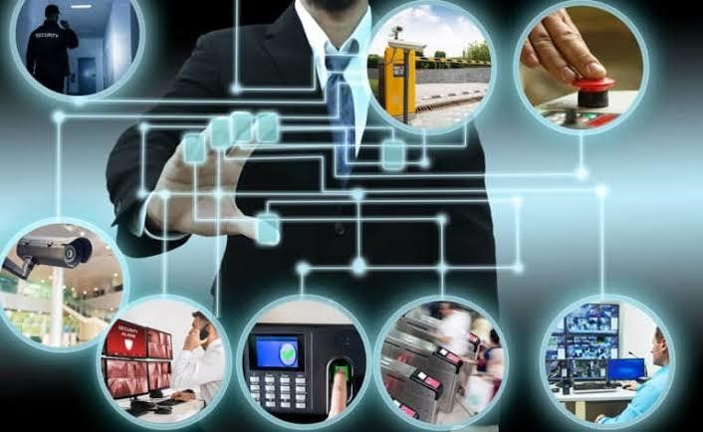

4.SMART SECURITY SYSTEM:

In AI, a smart security system leverages artificial intelligence to enhance and automate security processes. Here are some key features:

1. Advanced Surveillance:

AI-powered cameras and sensors use machine learning algorithms to detect and analyze unusual behavior, such as intrusions or suspicious activity. This includes recognizing faces, identifying objects, and differentiating between types of motion.

1. Predictive Analytics:

AI systems can analyze patterns and trends to predict potential security threats before they occur, improving preventive measures.

1. Automated Responses:

Based on AI analysis, the system can trigger automated responses, such as sending alerts, activating alarms, or even contacting emergency services.

1. Behavioral Analysis:

AI can learn and understand normal behavior patterns in a given environment, enabling it to identify anomalies that could indicate a security threat.5. Integration with Other AI Systems: Smart security systems often integrate with other AI systems, such as smart home devices or city surveillance networks, for comprehensive security management.

Overall, AI enhances the capability of smart security systems by making them more responsive, adaptive, and efficient in detecting and responding to security threats.

4.1-TYPES OF SMART SECURITY SYSTEM:

AI-driven smart security systems come in various types, each leveraging artificial intelligence to enhance security measures. Here are some common types:

1. Smart Surveillance Cameras:

Equipped with AI algorithms, these cameras can detect and recognize faces, analyze movements, and identify unusual activities. They often feature real-time monitoring and alerting capabilities.

1. Intrusion Detection Systems:

These use AI to monitor for unauthorized access or suspicious behavior. They can analyze patterns and distinguish between normal and abnormal activity, reducing false alarms.

1. Facial Recognition Systems:

AI-powered facial recognition systems can identify and verify individuals based on facial features, providing secure access control and monitoring.

1. Behavioral Analytics:

These systems use AI to analyze behavior patterns over time and detect anomalies that may indicate potential security threats.

1. Predictive Security Systems:

By analyzing historical data and trends, these systems can predict and preempt potential security incidents before they occur.

1. Smart Alarm Systems:

AI enhances alarm systems by analyzing data from various sensors to differentiate between actual threats and false alarms, improving response accuracy.

1. Integrated Security Platforms:

These systems combine multiple AI-driven components, such as cameras, sensors, and alarms, into a unified platform for comprehensive security management.

Each type uses AI to improve detection accuracy, reduce false positives, and automate responses, enhancing overall security effective systems.

4.1-DIAGRAM FOR SMART SECURITY SYSTEM:

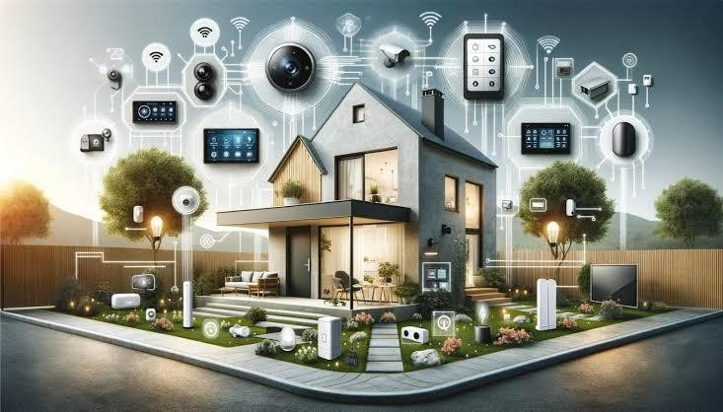

5.AI BASED SMART SECURITY SYSTEM:

AI smart security refers to security systems that use artificial intelligence to enhance the monitoring, detection, and response capabilities of security measures. These systems leverage AI technologies to offer more advanced and adaptive security solutions compared to traditional systems.

1. Enhanced Detection:

AI algorithms can analyze video feeds and sensor data to identify threats with high accuracy, such as recognizing faces, detecting unusual movements, or identifying specific objects.

1. Real-time Analysis:

AI systems process data in real-time to provide instant alerts and responses, improving the speed and effectiveness of security measures.

1. Adaptive Learning:

AI can learn from historical data and continuously improve its detection capabilities, adapting to new types of threats and changing patterns.

Overall, AI smart security systems offer increased accuracy, efficiency, and adaptability, providing more sophisticated and reliable protection for homes, businesses, and public spaces.

5.2-TYPES OF AI BASED SMART SECURITY SYSTEM:

AI-based smart security systems come in various types, each utilizing artificial intelligence to enhance different aspects of security. Here are some key types:

1. AI-Powered Surveillance Cameras:

These cameras use machine learning to analyze video footage in real-time, identifying and tracking individuals, detecting unusual activities, and distinguishing between different types of movement (e.g., people, animals, vehicles).

1. Facial Recognition Systems:

AI algorithms recognize and verify individuals' faces to control access to secure areas or monitor for known individuals in a given environment.

1. Behavioral Analytics Systems:

These systems use AI to analyze normal behavior patterns and detect anomalies or unusual behavior that may indicate a security threat.

Each type leverages AI to enhance accuracy, efficiency, and adaptability in detecting and responding to security threats.

5.2-DIAGRAM FOR AI BASED SMART SECURITY SYSTEM:

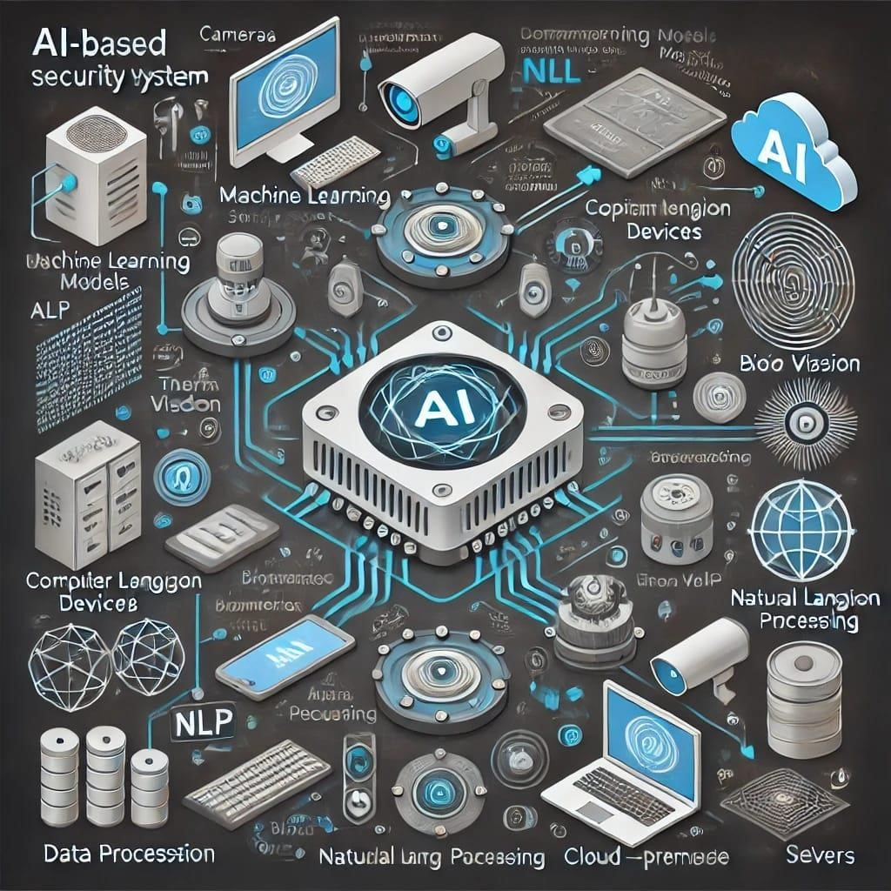

6.APPLICATIONS:

AI-based smart security systems have a range of applications that enhance security and efficiency. Here are some key areas where they are applied:

1. Face Recognition:

Identifying individuals through facial recognition for secure access control and monitoring.

1. Intrusion Detection:

Using AI to detect unusual behavior or movements within a protected area and trigger alarms.

1. Video Surveillance:

Enhancing traditional CCTV systems with AI to analyze video feeds for identifying potential threats or suspicious activities.

1. Behavior Analysis:

Monitoring and analyzing patterns in behavior to predict and prevent security breaches.

1. Access Control:

Automating entry and exit permissions based on biometric data, such as facial recognition or fingerprint scanning.

1. Emergency Response:

AI can prioritize alerts and coordinate with emergency services based on the severity of the detected threat.

7.ADVANTAGES:

AI-based smart security systems offer several advantages over traditional security solutions:

1. Enhanced Accuracy:

AI can improve the accuracy of threat detection through advanced algorithms and machine learning, reducing false alarms and missed threats.

1. Real-Time Monitoring:

AI systems can analyze data in realtime, providing immediate alerts and responses to potential security breaches.

1. Scalability:

AI systems can easily scale to cover large areas or multiple locations, adapting to growing security needs without significant additional costs.

1. Automated Responses:

Automated actions, such as locking doors or contacting authorities, can be triggered based on AI analysis, reducing the need for human intervention.

1. Predictive Analytics:

AI can analyze patterns and trends to predict potential security threats before they occur, allowing for proactive measures.

1. Cost Efficiency:

By reducing the need for extensive human monitoring and manual intervention, AI-based systems can lower long-term operational costs.

1. 24/7 Operation:

AI systems can continuously monitor and analyze security data around the clock without fatigue, ensuring constant vigilance.

These advantages make AI-based smart security systems a powerful tool for enhancing safety and efficiency in various environments.

8.DISADVANTAGES:

Despite their advantages, AI-based smart security systems also have some potential disadvantages:

1. Privacy Concerns:

The use of facial recognition and other monitoring technologies can raise privacy issues, as personal data may be collected and analyzed without explicit consent.

1. High Initial Costs:

The setup and integration of AI-based systems can be expensive, including costs for hardware, software, and installation.

1. Dependence on Technology:

Reliance on AI systems means that technical failures or malfunctions could compromise security.

1. Complexity:

AI systems can be complex to configure and maintain, requiring specialized knowledge and skills.

5.False Positives/Negatives:

While AI aims to reduce false alarms, there is still a risk of incorrect detections, which can lead to unnecessary panic or missed threats.

6.Data Security:

The storage and management of large volumes of sensitive data raise concerns about data security and potential breaches.

Addressing these disadvantages involves careful planning, implementation, and ongoing management to ensure that AIbased security systems function effectively and ethically.

CONCLUSION:

This AI-based smart security system represents a significant advancement in home and building security, combining the latest in artificial intelligence and IoT technology to deliver robust, real-time protection. Throughout the development of this project, we have integrated various cutting-edge technologies, including PIR sensors for motion detection, Convolutional Neural Networks (CNNs) for facial recognition, and natural language processing for sentence recognition. Each component works in tandem to provide a multilayered security approach that significantly enhances the system's accuracy and reliability. The use of PIR sensors ensures efficient detection of motion, activating the facial recognition module when necessary, which conserves resources and enhances system responsiveness. The implementation of CNNs allows for precise identification of individuals by analyses facial features, offering a high level of accuracy and reducing the chances of false positives. The additional layer of sentence recognition further strengthens the system by verifying identities through voice commands, ensuring that access is only granted to authorized users. Data integration techniques, such as edge computing and real-time data streaming, are crucial to the system’s functionality, enabling seamless communication between various sensors and processing units. This ensures that all data is processed quickly and accurately, allowing for immediate decision-making and timely alerts. The user interface is designed to be intuitive and accessible, providing users with real-time alerts, remote monitoring capabilities, and easy management of security settings through a mobile app or web portal. Overall, this project demonstrates the potential of integrating advanced AI technologies with traditional security measures to create a smart security system that is both effective and userfriendly. By enhancing the accuracy of threat detection and providing comprehensive monitoring capabilities, this system not only improves security but also offers peace of mind to users. The adaptability and scalability of the system make it suitable for a wide range of applications, from residential homes to commercial buildings and public spaces. As technology continues to evolve, this project lays the groundwork for future innovations in smart security solutions, paving the way for even more sophisticated and reliable systems.

REFERENCES:

1.Sana Ghafoor, Muhammad Rizwan Tahir.(2020). ResearchGate. https://www.researchgate.net/publication/341261991

2.Asif Rahim , Yanru Zhong , Tariq Ahmad. (2023). International Journal for Research in Applied Science & Engineering Technology (IJRASET). https://doi.org/10.22214/ijraset.2023.50243

3.Prashant Katiyar, Satish Singh, Ankit Kumar, Mr. Gautam Kumar,(2021). International Journal For Technological Research In Engineering(ISSN).

4.Nourman S. Irjanto , Nico Surantha.(2020). International Journal of Advanced Computer Science and Applications(IJACSA).

5.AKM Jahangir Alam Majumder.(2020). ResearchGate/ 2020 IEEE 44th Annual Computers, Software, and Applications Conference(COMPSAC).

6.Nitika Vats Doohan, Sandeep Kadam, Rajesh Phursule, Vinod S. Wadne, and Aparna Junnarkar (2022). International Journal of Electrical and Electronics Research (IJEER ).

7.Nourman S. Irjanto, Nico Surantha. (2020). (IJACSA) International Journal of Advanced Computer Science and Applications.

8.Aman Sharma,Aanjana Goen(2018). Research gate.